PRACTICE 4
Determine the validity of the following three statements. Circle either True or False.
1. Group functions work across many rows to produce one result per group.
True/False
>>> False
- Group functions include nulls in calculations.
True/False
>>>False
    - The WHERE clause restricts rows prior to inclusion in a group calculation.
True/False
>> False
The HR department needs the following reports:
4. Find the highest, lowest, sum, and average salary of all employees. Label the columns
Maximum, Minimum, Sum, and Average, respectively.
>>select max(salary) Maximum, min(salary) Minimum, sum(salary) Sum, avg(salary) Average
From employees;
- Modify the query in lab_04 to display the minimum, maximum, sum, and average salary for each job type.
>>select job_id,max(salary) Maximum, min(salary) Minimum, sum(salary) Sum, avg(salary) Average
From employees
Group by job_id; 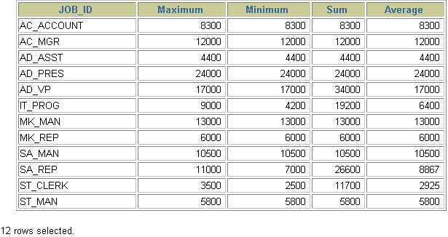
- Write a query to display the number of people with the same job.
>>select job_id,count(*)
From employees
Group by job_id;
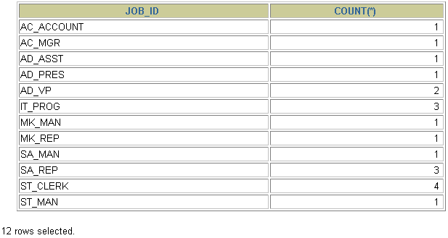
7. Determine the number of managers without listing them. Label the column Number of Managers.
>>select count(*) "Number of Managers"
From employees
group by manager_id;
8.Find the difference between the highest and lowest salaries. Label the column DIFFERENCE.
>> select max(salary)-min(salary) as DIFFERENCE
From employees;

